This marketing toolkit is for Seattle Employee Transportation Coordinators (ETCs), Building Transportation Coordinators (BTC), and representatives at Seattle businesses to promote the Seattle Commute Survey. The survey is live starting on Monday October 7th, 2024, and will close on Friday November 1st, 2024.
The 2024 Seattle Commute Survey and Mode Split Study is supported by the University of Washington Mobility Innovation Center and Challenge Seattle, in partnership with the Seattle Department of Transportation and Washington State Department of Transportation.

What is included in this Marketing & Communications Toolkit?
Contents
What is included in this Marketing & Communications Toolkit? 1
Raffle Prizes 2
Email Templates 2
IT Department (if needed) 2
Leadership (if needed) 2
Managers and Supervisors (1 week before Survey Start Day, September 30) 3
Survey is Coming (1 week before Start Day, September 30; send after Managers/Supervisors) 3
Survey is Live (Survey Start Day, October 7) 4
Survey Reminder Response Rate Goal Not Yet Met (1 week before Survey Close, October 28) 5
Survey Reminder Response Rate Goal Met (1 week before Survey Close, October 28) 5
Survey Closed and Thank you! 6
Employee Communication: Special Prize Winner! 6
Digital Banners 7
Commute Survey Coming! 7
Why a Commute Survey? 7
Thank you! 8
Print Materials & QR Code 9
Poster – 11 x 17in Portrait 9
Letter – 8.5 x 11in Portrait 9

Raffle Prizes
Raffles can be a way to boost excitement and your response rate. If you would like to do an internal raffle for your company and/or building check and make sure it follows your company policies and procedures.
Raffle prizes could be a gift card, lunch for their team, or another simple perk. We can provide an email list of the staff that completed the survey in order to draw a winner from. These email addresses are not tied to the survey responses in any way and will be deleted on 1/6/25.

Email Templates
Please use these email templates to communicate the survey to the necessary people.

IT Department (if needed)
Suggested Subject: Save the Date: Seattle Commute Survey Coming October 2024
We have a state-mandated transportation survey starting on Monday October 7th, 2024. Employees will complete the survey online using Qualtrics, a tool provided by the University of Washington. On Monday October 7th, 2024, we will send a hyperlink and instructions to employees. Click here to preview the questions online.
The survey tool is entirely web-based and requires individuals to have access to the internet or a smartphone to complete it. There are no other technical requirements. Data privacy and storage standards are consistent with the City of Seattle Privacy Policy and the UW Institutional Research Board. We will not need to store data or operate the system on our servers, and nothing gets installed on our system.
Thank you,
<<Name>>, Transportation Coordinator
<<Email>> | <<Phone>>

Leadership (if needed)
Suggested Subject: Seattle Commute Survey Coming October 2024
State law requires that we survey our employees regarding their commuting habits. State and local governments use this data to make decisions about transportation investments and improvements. Internally, we use the survey results to determine possible updates to our commuter benefit packages.
On Monday October 7th, 2024, an email will be sent to all employees asking them to complete the survey. The email will contain a link to the website where employees will complete the survey. The survey contains both required and optional questions. The required questions should take less than five minutes to complete and the optional questions between 5-10 minutes. Click here to Preview the questions online.
We are one of 800 employers in Washington State participating in the survey. Local ordinances require a significant response from our worksite. It’s important that everyone participates, not just employees who use alternatives to driving alone to work.
More information about Washington State’s Commute Trip Reduction (CTR) law is available here.
If you have any questions, please contact me directly.
Thank you,
<<Name>>, Transportation Coordinator
<<Email>> | <<Phone>>

Managers and Supervisors (1 week before Survey Start Day, September 30)
Suggested Subject: Action Requested: Seattle Commute Survey Coming October 2024
State law requires <<Company Name>> to survey our employees regarding their commuting habits. State and local governments use this data to make decisions about transportation investments and improvements. Internally, we use the survey results to determine possible updates to our commuter benefit packages.
This coming Monday October 7th, 2024, an email will be sent to all employees asking them to complete the survey. The email will contain a link to the website where employees will complete the survey. The survey contains both required and optional questions. The required questions should take less than five minutes to complete and the optional questions between 5-10 minutes.
We are one of 800 employers in Washington State participating in the survey. Local ordinances require a significant response from our worksite. It’s important that everyone participates, not just employees who use alternatives to driving alone to work, so we are asking for your help in reminding your teams to complete this required survey.
If you have any questions, please contact me directly.
Thank you,
<<Name>>, Transportation Coordinator
<<Email>> | <<Phone>>

Survey is Coming (1 week before Start Day, September 30; send after Managers/Supervisors)
Suggested Subject: Save the Date: Seattle Commute Survey Coming October 7
The Seattle Commute Survey is coming up next Monday October 7th, 2024. The survey contains both required and optional questions. The required questions should take less than five minutes to complete and the optional questions between 5-10 minutes. All employees should complete the survey.
We are completing the survey online. We will send an email on Monday announcing the survey and sharing our company’s survey link.
This statewide survey gathers information about how over 400,000 employees in Washington State commute to work. Having accurate data about commuting is important to state and local governments in deciding how to invest our tax dollars in transportation. We will also use your information in-house to determine possible adjustments to your commuter benefits package.
If you have any questions, please contact <<Name>> at <<Email>> or <<Phone>>.
Kindly,
<<Name>>, Transportation Coordinator
<<Email>> | <<Phone>>

Survey is Live (Survey Start Day, October 7)
Suggested Subject: Immediate Action Requested: Take the Seattle Commute Survey
The Seattle Commute Survey is Live! The survey contains both required and optional questions. The required questions should take less than five minutes to complete and the optional questions between 5-10 minutes. All employees should complete the survey, not just those who use alternatives to driving alone to work.
Complete the survey online: <<CUSTOM LINK>> This link is our company’s specific survey link with our name already filled out.
This statewide survey gathers information about how over 400,000 employees in Washington State commute to work. Having accurate data about commuting is important to state and local governments in deciding how to invest our tax dollars in transportation. We will also use your information in-house to determine possible adjustments to your commuter benefits package.
If you have any questions, please contact <<Name>> at <<Email>> or <<Phone>>.
<<Closing Option 1: Thank you for completing your survey.>>
<<Closing Option 2: To make this survey more fun, we are holding a special prize drawing for <<insert prize>> from the pool of employees who complete the survey! Don’t wait and miss out on the prize! >>
Kindly,
<<Name>>, Transportation Coordinator
<<Email>> | <<Phone>>

Survey Reminder Response Rate Goal Not Yet Met (1 week before Survey Close, October 28)
Suggested Subject: Final Reminder: Take the Seattle Commute Survey
The deadline for the Seattle Commute Survey is rapidly approaching. You have until November 1st to complete the survey. We are required to achieve a <<Required Response Rate Goal%>> response rate. We have not met our goal yet. Your participation is critical in not only meeting the state mandate but also for upcoming decisions on transportation investment and our company’s commuter benefits. The survey contains both required and optional questions. The required questions should take less than five minutes to complete and the optional questions between 5-10 minutes.
Complete the survey online: <<CUSTOM LINK>> This link is our company’s specific survey link with our name already filled out.
If you need help or have additional questions, you can reach me at <<Email>> or <<Phone>>.
<<Closing Option 1: Thank you for completing your survey.>>
<<Closing Option 2: To make this survey more fun, we are holding a special prize drawing for <<insert prize>> from the pool of employees who complete the survey! Don’t wait and miss out on the prize! >>
Kindly,
<<Name>>, Transportation Coordinator
<<Email>> | <<Phone>>

Survey Reminder Response Rate Goal Met (1 week before Survey Close, October 28)
Suggested Subject: Final Reminder: Take the Seattle Commute Survey
The deadline for the Seattle Commute Survey is rapidly approaching. You have until November 1st to complete the survey. We have met our response rate goal of <<Response Rate Goal>>%! You can still participate though. Our responses go not only towards meeting the state mandate but are also used for upcoming decisions on transportation investment and our company’s commuter benefits. The survey contains both required and optional questions. The required questions should take less than five minutes to complete and the optional questions between 5-10 minutes.
Complete the survey online: <<CUSTOM LINK>> This link is our company’s specific survey link with our name already filled out.
If you need help or have additional questions, you can reach me at <<Email>> or <<Phone>>.
<<Closing Option 1: Thank you for completing your survey.>>
<<Closing Option 2: To make this survey more fun, we are holding a special prize drawing for <<insert prize>> from the pool of employees who complete the survey! Don’t wait and miss out on the prize! >>
Kindly,
<<Name>>, Transportation Coordinator
<<Email>> | <<Phone>>

Survey Closed and Thank you!
Suggested Subject: Thank you for completing the Seattle Commute Survey!
Thank you for your participation in the Seattle Commute Survey! Your input will help guide transit service, capital investment, and public policy now and into the future.
The survey is now closed. Commute Seattle and the University of Washington Mobility Innovation Center are cleaning, processing, analyzing, and summarizing the survey data. High-level general results will be available by January 2025 and our company report by March 2025. If you have any questions, please contact <<Name>> at <<Email>> or <<Phone>>.
Commute Seattle is here to help with our transportation needs! Email info@commuteseattle.com to learn more about climate-friendly travel options!
Kindly,
<<Name>>, Transportation Coordinator
<<Email>> | <<Phone>>

Employee Communication: Special Prize Winner!
Suggested Subject: The Seattle Commute Survey Prize Winner!
Thank you everyone for your participation in the Seattle Commute Survey! Your input will help guide transit service, capital investment, and public policy now and into the future.
Drawing from all the participants, <<Employee Name>> has won <<prize>>! Congratulations!
If you have any questions, please contact <<Name>> at <<Email>> or <<Phone>>.
Commute Seattle is here to help with our transportation needs! Email info@commuteseattle.com to learn more about climate-friendly travel options!
Kindly,
<<Name>>, Transportation Coordinator
<<Email>> | <<Phone>>

Digital Banners
Right click the photo(s) below to “Save as Picture” to your computer.

Commute Survey Coming!
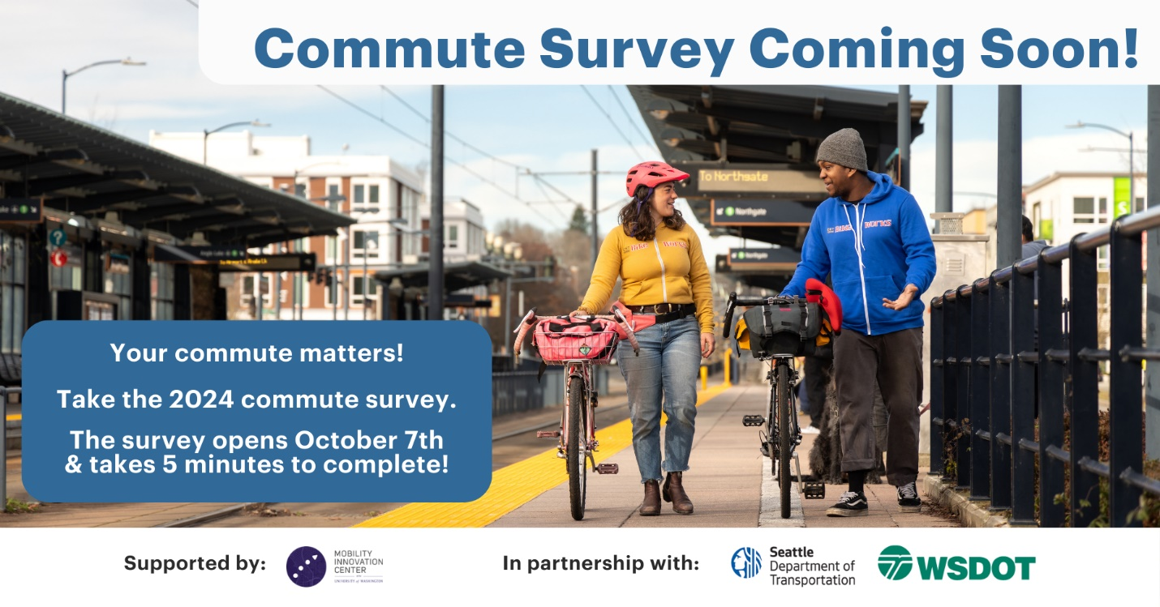

Why a Commute Survey?
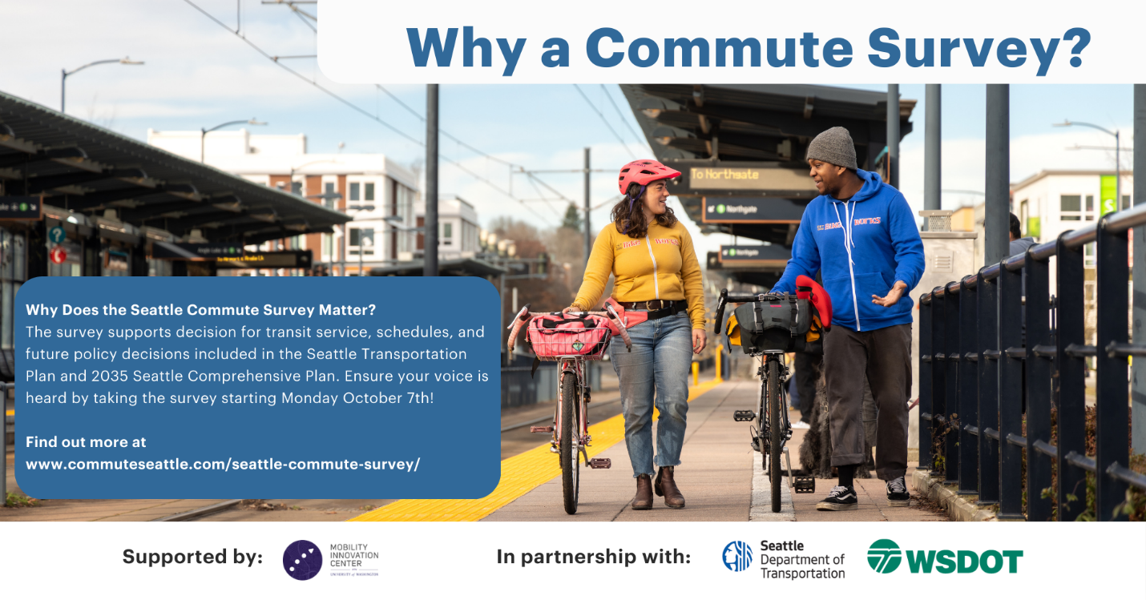

Thank you!
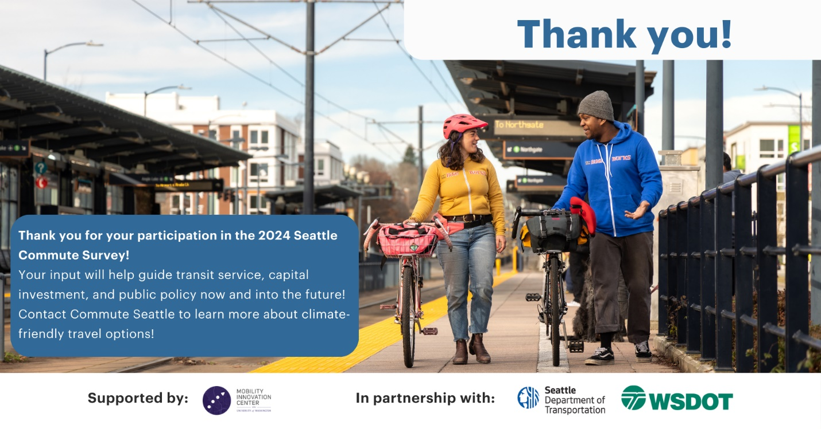

Print Materials & QR Code
Here are two options for printed posters. If you want a site specific QR code to your company’s URL please reach out to our CTR and TMP team at ctr@commuteseattle.com and tmp@commuteseattle.com and we’d be happy to send you a custom QR code.

Poster – 11 x 17in Portrait
https://www.commuteseattle.com/wp-content/uploads/2024/09/2024-Your-Commute-Matters_Poster.pdf.pdf

Letter – 8.5 x 11in Portrait
https://www.commuteseattle.com/wp-content/uploads/2024/09/2024-Your-Commute-Matters_Letter.pdf.pdf

